Tight Coupling & Loose Coupling
Tight Coupling
- Classes are highly dependent on each other while internal working.
- A change in one class often requires the change in another class.
- Tight Coupling can make code harder to maintain and test.
Loose Coupling
- Classes are more independent and relies on interfaces for abstraction.
- A class only knows what another class can do, not how it does it.
- Loose Coupling improves code maintainability, reusability and testability.
//TightandLooseCoupling

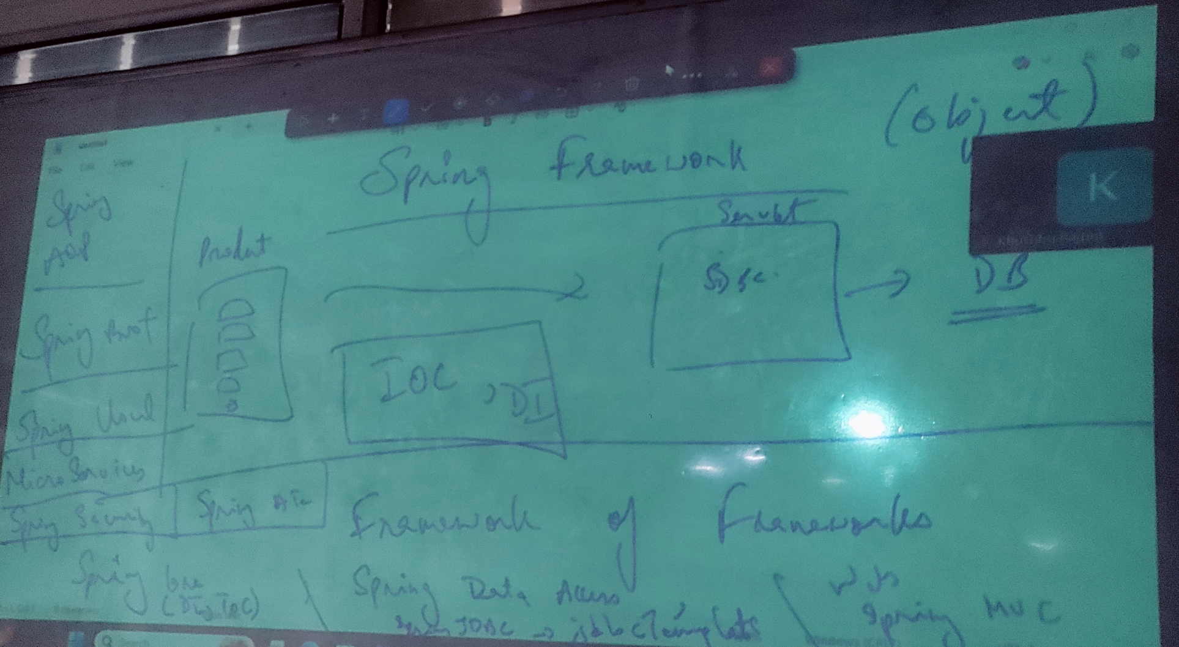

Spring Framework
Spring Framework is popular open-source framework for building enterprise application in java. It is known for being very light weight and modular which means, we can pick and choose the features that we need for our project. We also call it framework of frameworks
Advantages:
- Core Features - IOC (Inversion of Control), DI (Dependency Injection), Data Access (JPA template, JDBC template), Web Application (Spring MVC), Spring Boot, Spring Security, etc.
- Focus on Business logics -Spring takes care of low-level details of application development such as DB connection and transaction management. This helps us to focus on writing core business logics of our application.
- Spring application are loosely coupled; it is loosely coupled because of beans of DI.
- It is lightweight because of POJO.
- It is easy for testing and as modular architecture.

Core Spring

IOC (Inversion of Control)
Spring introduced an IOC container usually represented by Application Context Interface. This container takes control of object creation, configuration and dependency management.
We define our bean objects and their configuration in Xml files or using java annotations. The IOC container reach this configuration / information’s and manages object based on them.
- DI (Dependency Injection) IMP for interview
DI is core principle used by the spring container to implement IOC. Is the process of providing an object with its dependencies rather than the object creating them itself (here dependencies mean data or information)
Spring injects dependencies into objects using various mechanism
- Constructor Injection – Dependencies are passed as arguments to the object constructors.
- Setter Injection – Dependencies are injected by calling by setter methods on the objects.

Working of IOC & DI together: -
- We define our bean objects in Spring configuration, specifying the dependencies (data).
- The Container creates the bean instances.
- During object creation, the container injects the required dependencies (data) using the chosen DI mechanism.
- The injected dependencies (data) are ready for use by the objects fulfilling its purpose.

Spring Beans
Spring Beans are the foundation of DI in spring application. They essentially are objects that are managed by the spring container. The Spring container creates, configures and manages the life cycle of spring beans creates configures and manages the life cycle of spring beans.
Life Cycle of Beans
- Instantiation
The spring container (IOC) creates and instance of bean class.
- Population
After the bean is instantiated spring populates its properties, the values from bean definition.
- Initialization
Spring invokes any initialization method that has been defined on the bean class, This initialization method is annotated with post construct.
- Usage
The bean is available for use by the spring container in the application.
- Destruction
When spring container shuts down or when the bean is no longer needed, spring invokes any destruction method that has been defined on the bean class. This destruction method is annotated with pre destroy.

Bean Scope imp for interview
Spring provides different scopes for beans which determines a lifetime of a bean instance and how many instances are created for a particular bean definition.
- Singleton - Only one instance of bean is created for the entire spring application context. Any request for the bean with the same name will return the same object reference.
Use case: Configurations object, utility classes, etc.
- Prototype - A new instance of the bean is created every time bean is requested from the spring container.
Use case: Session objects used in calculations, etc.
- Request (Web based) - In a web application new instance of bean is created for each http request.
- Session (Web based) - In a web application a new instance of bean is created for each http session.
- Application (Web based) – In an application only one instance of bean is created for the entire application. This is similar to singleton scope but it is specific to web application context.

Project1:SpringXml1
POJO
- 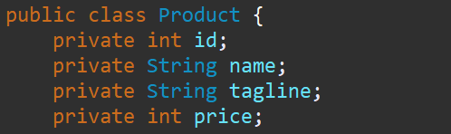
applicationContext.xml
1.Setter inejection
- 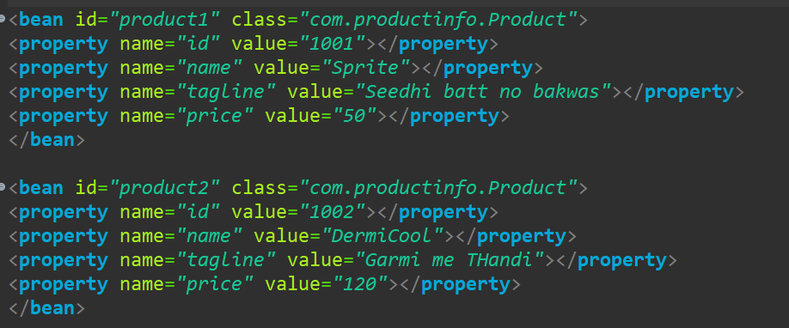
Main
- 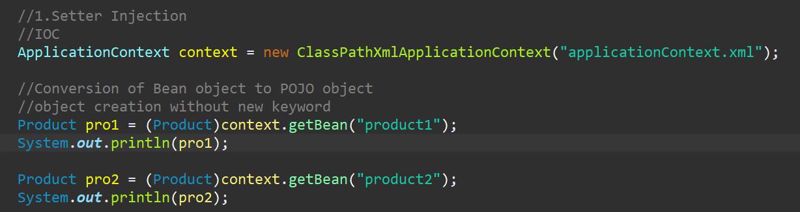
2.Constructor injection
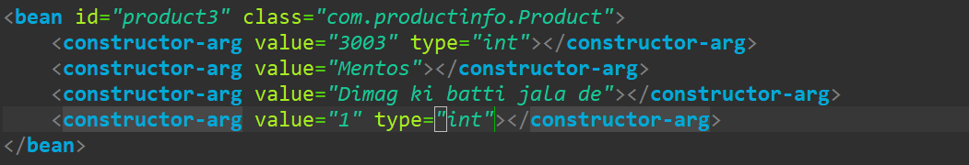Change java version if code doesn’t work
Project2: Spring2xmlUdanFlights
- Create a customer POJO
- Create a Flights POJO with a has a relationship with customer
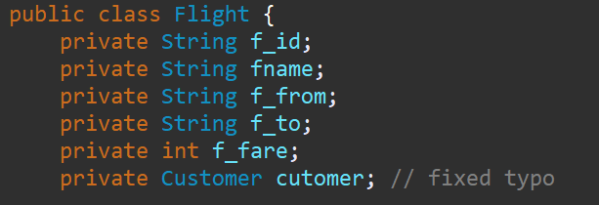
- Cerate a beans of Customer
- Create a beans of Flight
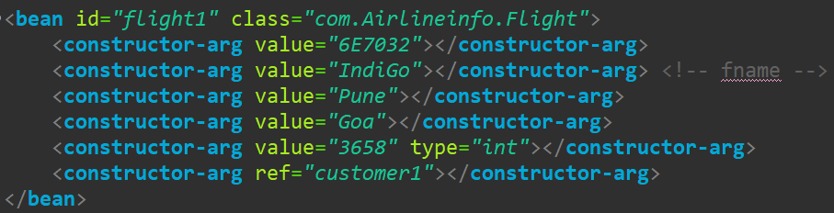
- Execute it in Main Class

SpringAnnoExample3
- Employee POJO
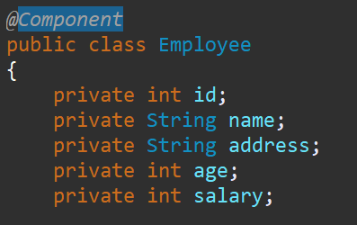
- AppConfig.java
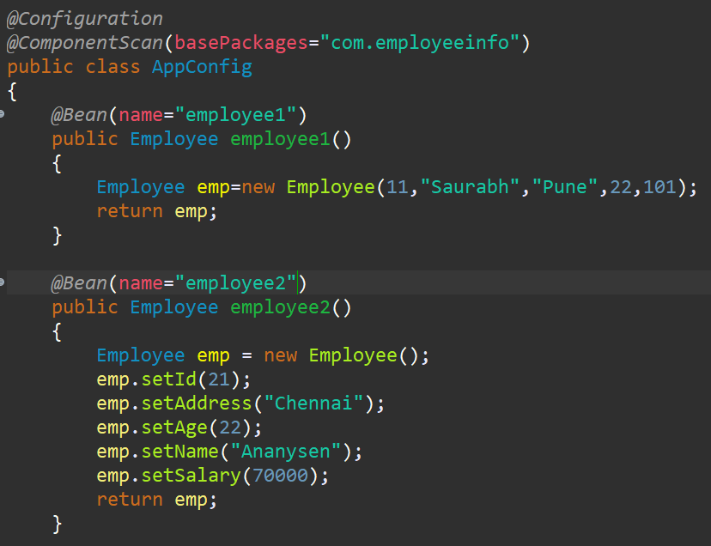
- MainClass.java
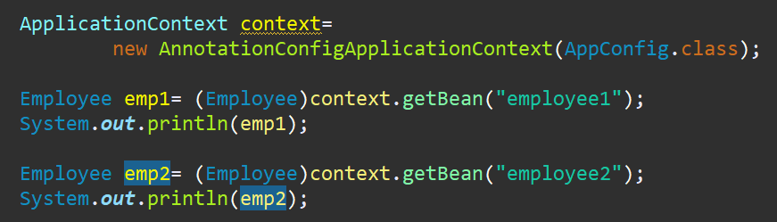

SpringAnnoExample3(Updated)
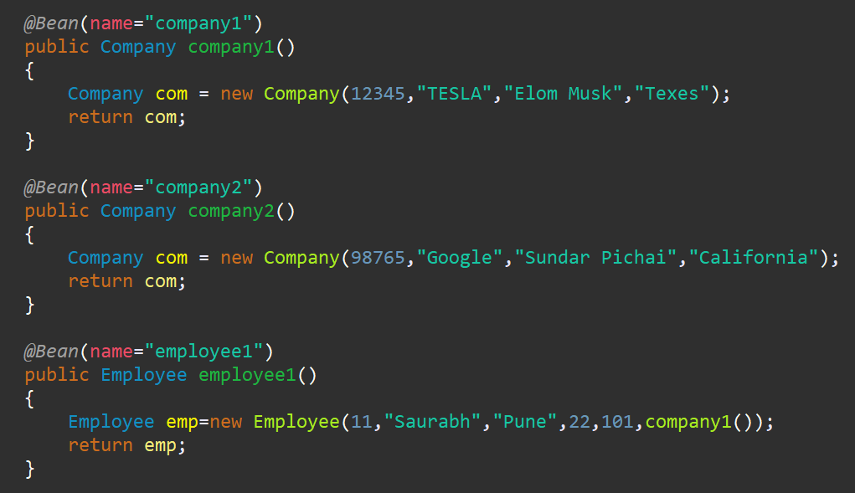
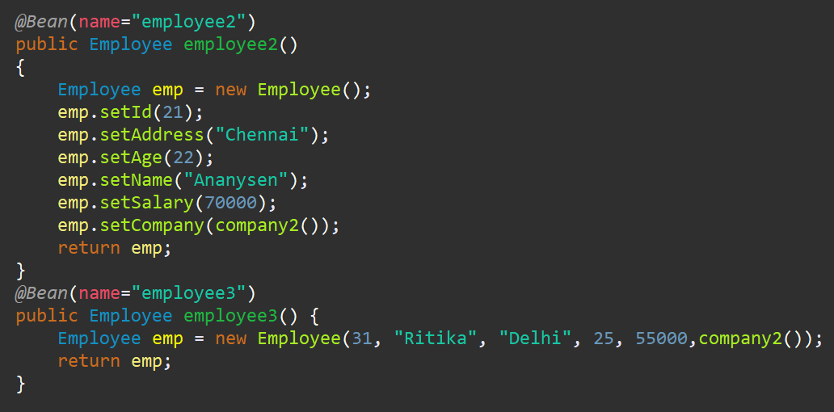

Auto-wiring
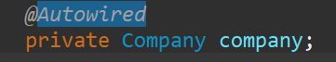
Remove @Component annotation of Company and also remove It from employee constructor and setter
And keep only one company
But in case of multiple companies add @Primary annotation
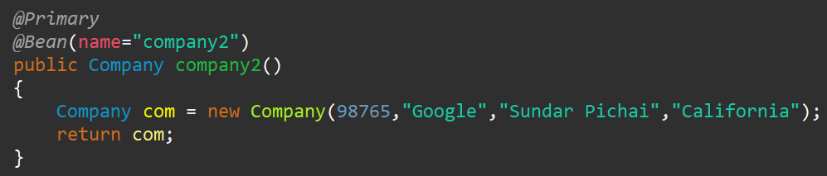
or
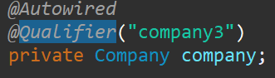
If both are applied preference is given to Qualifier

>>SPRINGJDBCEXAMPLE
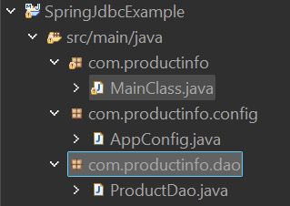

Spring MVC (very IMP 100% for interviews)

Front Controller
Dispatcher Servlet
Controller
requests
Client
Controller

Controller

SPRING MVC
Front Controller
Dispatcher Servlet

requests (Model)
Client
Controller

response (Model)

View

Sprig MVC (Manual Configurations)
Sprig MVC is a popular java framework for building web applications and follows model view controller pattern
Core Components: -
- Dispatcher Servlet: It acts as the front controller, receiving all incoming http requests, it then redirects them the appropriate components based on configurations.
- Controllers: It is the main component that handle user requests. They interact with model, process data and select the appropriate view. Spring controller are typically annoted with @controller and @requestmappping to map url to controller methods.
- Model: It represents application data. It can be a simple java bean or more complex object, holding business logic.
- View: It is responsible for presenting the data to the user. Spring MVC supports various view technologies like JSP, thyme leaf, JSON, etc.

//TravelBookingSpringMVC1

Spring MVC workflow
- A User interacts with the web application sending an HTTP request.
- Dispatcher servlets intersect the incoming request.
- Dispatcher servlet converts the angler mapping component to find appropriate controller method that should handle the request, this is typically defined using annotation like @requestmapping on the controller method.
- The Dispatcher Servlet then invokes the identified controller method.
- The controller interacts with the model, for retrieving or updating the data and to select appropriate view to display the results.
- The controller typically returns model view object which contains the data to be displayed and the view name. The dispatcher servlet uses a view resolver component to locate actual view template based on view name.
- The dispatcher servlet renders the view with the data from the model and sends the final HTML response to the user browser.
Advantage: -
Clear separation of presentation logic, business logic and user interaction.

//Spring2XMLUdanFlights
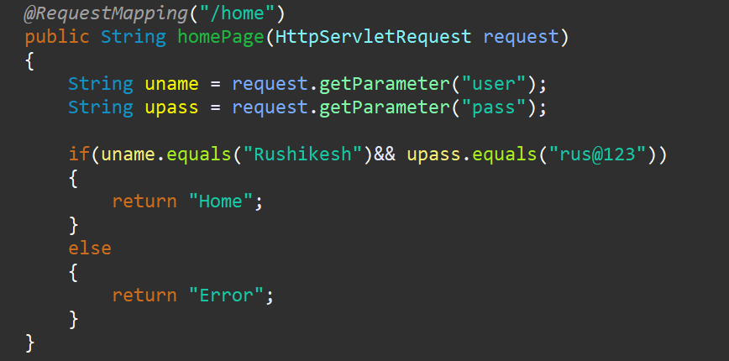

Spring Boot
It is a popular open-source framework, build on top of Spring framework that simplifies the creation of java applications and web applications.
Spring Framework + Embedded Server–Bean, xml configuration= Spring Boot
Features
- Faster Development
  - Reduce boiler plate code.
  - Convention over configuration
  - Embedded Server
- Improved Productivity
  - Spring Initializer (start.spring.io) – It is web tool that allows us to quickly setup a spring boot project with required libraries.
  - Starters – Spring boot provides pre-configured starter dependencies that abundant commonly used libraries from functionality like web development, data access, etc.
  - Auto-configuration - Spring boot can auto configuration many aspects of our application based on libraries we include.

//PehlaSpringBoot

Web Services
//WEBSERVICES DIAGRAM
Web Service is a software application that uses standardized protocols to exchange data with other applications over the internet. It acts a bridge allowing different systems to communicate and share information seamlessly.
Types of Web Services
- SOAP (Simple Object Access Protocol)
- Rest (Representational State Transfer)
SOAP
It is protocol-based approaches that uses xml messages to exchange information. It offers robust security features and complex data exchange capabilities. It is well suited for enterprise application that require strict data validation and security.
REST
It is a architectural style that leverages HTTP methods (get, post, put, delete) to interact with the web services it is simpler and more light weight and soap.
It is ideal for modern web applications that require high performance and scalability.

Key Concepts of REST API
- Resources
These are core concepts in rest, a resource can be anything that can be identified such as document, image or service.
- Representations
When a client requests a resource a server sends back a representation of a JSON or other format. (99% JSON)
- HTTP methods
Rest uses HTTP methods (get, post, put, delete) to perform action on resources.

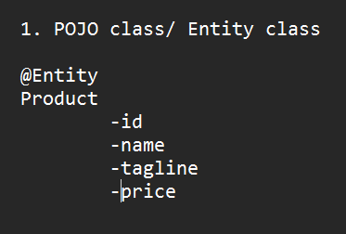
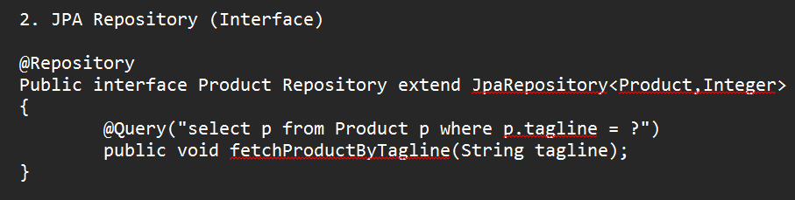
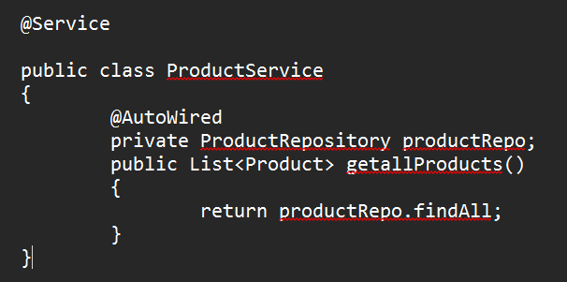
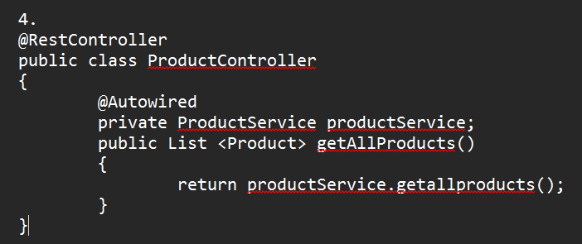

Spring Security
It is a powerful and flexible framework for securing Spring based applications using authentication and authorization.
Authentication
It is the process of verifying the identity of the user or system attending to access a resource.
Example: Password based authentication, Multi factor authentication (MFA), biometric authentication.
Authorization
It is the process of determining what actions an authenticated users or systems are allowed to perform on a resource.
Example: Role based authorization – a user with manager role can approve or reject employee leave request while a user within employee role can only submit leave request.

Spring boot security auto configures below features >>>
- Spring-boot-starter-security:
- It aggregates the spring security related dependency together.
- It enables spring security’s default configurations which creates a servlet filter as a bean name SecurityFilterChain. This bean is responsible for the all the security within your application.
- Form based authentication is enabled by default.
- It creates default user with username and ‘user’ and randomly generated password in your console.
- Spring boot also provides properties to customize default username and password.
- CSRF (cross site request forgery) attack prevention is enabled by default.

Micro Services
Microservices is an approach to develop a single application as a suite of small services, each running its own process and communicating with light weight mechanisms, with around business capabilities and independently deployable by fully automated deployment machinery.
Every Microservice has its own server and independent database.
Spring Cloud
It is a framework build on top of spring boot that helps developers build distribute system and microservice architecture easily. Instead of writing everything from scratch Spring cloud provides ready-made tools from common problems in microservice.
Spring cloud provide solution for
- Service discovery
- Load Balancing
- Configuration Management
- Fault tolerance
- API gateway routing
Spring Cloud – Netflix
It is collection of tools from Netflix that helps build scalable microservices using spring cloud.
Core Netflix Components:
Eureka – Service Discovery
Ribbon – Load Balance, Spring Cloud load balance
Hystrix – Circuit Breaker
Zuul – API Gateway, Spring Cloud Gatteway
Feign –

